**MULTIMODEL AUTHENTICATION SECURITY SYSTEM**

**ABSTRACT**

In the realm of security systems, the demand for robust authentication methods is continually evolving to counteract potential threats effectively. To address this need, the project "Multimodal Authentication Security" has been conceived, presenting an innovative approach to door unlocking mechanisms by amalgamating multiple layers of security measures.

The system integrates various biometric modalities, namely facial recognition and fingerprint authentication, along with an additional layer of one-time password (OTP) verification for enhanced security. The architecture of the system involves a user interface running on a laptop, interfacing with a microcontroller embedded within the door locking mechanism.

The user initiates the authentication process by undergoing facial recognition through the user interface. Upon successful identification, a signal is transmitted to the microcontroller to prompt the user for fingerprint authentication. The microcontroller communicates with the fingerprint device to capture the user's fingerprint data, which is then relayed back to the laptop for verification against stored biometric records.

Upon positive verification of the fingerprint data, an OTP is generated and sent to the user's registered email address. The user enters the OTP into the interface, which is cross-validated with the generated OTP. Upon successful validation, a final signal is sent to the microcontroller to actuate the door locking mechanism, granting access to the user.

This multimodal authentication system provides a robust and layered security approach, leveraging the strengths of different biometric modalities and OTP verification to ensure secure access control. By incorporating multiple layers of authentication, the system mitigates the risk of unauthorized access, thereby enhancing the overall security posture of the protected premises.

**OBJECTIVES**

1. Enhanced Security: The primary objective of the project is to develop a highly secure authentication system for door access control. By integrating multiple biometric modalities such as facial recognition and fingerprint authentication, along with an additional layer of OTP verification, the system aims to establish a robust and reliable means of user identification.

2. User-Friendly Interface: The project focuses on creating a user-friendly interface that simplifies the authentication process for end-users. The interface should be intuitive and easy to navigate, guiding users through each step of the authentication process seamlessly.

3. Integration with Microcontroller: Integrating the authentication system with a microcontroller embedded within the door locking mechanism is essential. The microcontroller acts as the intermediary between the user interface and the physical door lock, facilitating communication and control of the locking mechanism based on the authentication results.

4. Real-Time Response: The system aims to provide real-time response to authentication requests, ensuring swift and efficient access control. Upon successful authentication, the door locking mechanism should be promptly actuated to grant access to authorized users without delay.

**EXISTING SYSTEM**

The existing door access control system operates on a conventional authentication method, primarily relying on physical keys or basic electronic keypads. This system lacks the sophistication and robustness required to address modern security challenges adequately. The absence of biometric authentication and advanced security features leaves the system vulnerable to unauthorized access and compromises the overall security posture.

Main Features of the Old Existing System:

1. Traditional Authentication: The old system relies on traditional authentication methods such as physical keys or electronic keypads with passcodes. Users are granted access based solely on possession of the correct key or knowledge of the passcode.

2. Limited Security: Due to the reliance on basic authentication mechanisms, the security offered by the old system is limited. It lacks the advanced features necessary to mitigate sophisticated threats such as unauthorized key duplication or brute force attacks on passcodes.

3. Lack of Accountability: The absence of user identification and authentication tracking capabilities results in a lack of accountability for access events. There is no mechanism to monitor and audit access attempts or to identify the individuals accessing the premises.

4. Vulnerability to Key Loss or Theft: The reliance on physical keys makes the system vulnerable to key loss, theft, or unauthorized duplication. In the event of key compromise, there are limited measures in place to prevent unauthorized access or to invalidate compromised keys.

5. Inconvenience and Limitations: Users may experience inconvenience due to the need to carry and manage physical keys. Additionally, the system lacks flexibility and scalability, making it challenging to accommodate changes in access permissions or to integrate with modern security technologies.

6. Limited Access Control: The old system offers limited control over access permissions and does not support granular access control policies. It cannot differentiate between authorized and unauthorized users or enforce access restrictions based on user roles or time-based criteria.

**PROPOSED SYSTEM**

The proposed "Multimodal Authentication Security" system aims to revolutionize door access control by introducing a sophisticated and multi-layered authentication framework. By integrating multiple biometric modalities, including facial recognition and fingerprint authentication, along with an additional layer of one-time password (OTP) verification, the system offers unparalleled security and user experience. The architecture involves a user interface running on a laptop, interfacing with a microcontroller embedded within the door locking mechanism. This system provides a robust and reliable means of user identification, mitigating the risk of unauthorized access and enhancing overall security posture.

Key Features of the Proposed System:

1. Multimodal Biometric Authentication: The proposed system leverages multiple biometric modalities, including facial recognition and fingerprint authentication, to enhance the accuracy and reliability of user identification. By combining these modalities, the system can effectively differentiate between authorized and unauthorized users, minimizing the risk of false positives.

2. One-Time Password (OTP) Verification: In addition to biometric authentication, the system incorporates an OTP verification mechanism to further strengthen security. Upon successful biometric authentication, an OTP is generated and sent to the user's registered email address. The user must enter the OTP to complete the authentication process and gain access.

3. Microcontroller Integration: The system interfaces with a microcontroller embedded within the door locking mechanism to control access based on authentication results. The microcontroller communicates with biometric devices to capture and verify user data, as well as manage the actuation of the door locking mechanism.

4. User-Friendly Interface: The system features a user-friendly interface running on a laptop, guiding users through the authentication process seamlessly. The interface provides clear instructions for facial recognition, fingerprint authentication, and OTP verification, ensuring a smooth user experience.

**ARCHITECTURE**

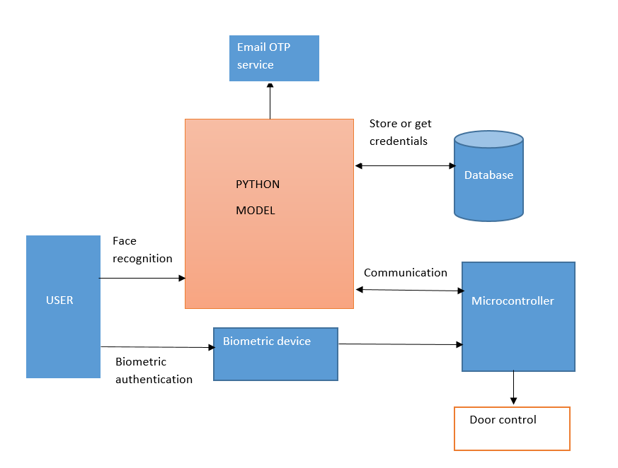

**MODULES DESCRIPTION**

1. User Interface Module:

- Description: This module provides the graphical user interface (GUI) for users to interact with the authentication system. It guides users through the authentication process, prompts them for biometric data, and displays authentication results.

- Components:

- GUI Components: Buttons, text fields, labels, etc., for user interaction.

- Facial Recognition Interface: Displays camera feed and instructions for facial recognition.

- Fingerprint Authentication Interface: Prompts users to scan their fingerprint.

- OTP Verification Interface: Displays input field for OTP entry.

- Dependencies: GUI libraries such as Tkinter (for Python), or Qt.

2. Biometric Authentication Module:

- Description: This module handles the capture and verification of biometric data, including facial recognition and fingerprint authentication.

- Components:

- Facial Recognition Algorithm: Detects and verifies faces captured by the camera.

- Fingerprint Authentication Algorithm: Interfaces with the fingerprint scanner to capture and verify fingerprints.

- Data Processing: Pre-processes biometric data for matching and verification.

- Dependencies: Image processing libraries (e.g., OpenCV for facial recognition), SDKs for fingerprint scanners.

3. Microcontroller Interface Module:

- Description: This module facilitates communication with the microcontroller embedded within the door locking mechanism.

- Components:

- USB Communication: Establishes communication channels with the microcontroller.

- Data Exchange Protocol: Defines protocols for sending authentication data and receiving control signals.

- Dependencies: Serial communication libraries (e.g., pySerial for Python) .

4. OTP Generation and Verification Module:

- Description: This module manages the generation and verification of one-time passwords (OTPs) sent to users' email addresses.

- Components:

- OTP Generation: Generates random OTPs for each authentication attempt.

- Email Sending: Sends OTPs to users' registered email addresses.

- OTP Verification: Validates OTPs entered by users during the authentication process.

- Dependencies: Email sending libraries (e.g., smtplib for Python), cryptography libraries for secure OTP generation.

5. Database Management Module:

- Description: This module handles the storage and management of biometric data, user profiles, and authentication logs.

- Components:

- User Profile Management: Stores and retrieves user profiles, including biometric data and access permissions.

- Dependencies: Database management system (e.g., MySQL), database interface libraries

6. Main Control Module:

- Description: This module coordinates the interaction between all other modules and manages the overall authentication process.

- Components:

- Authentication Flow Control: Orchestrates the flow of authentication steps, including facial recognition, fingerprint authentication, OTP generation, and verification.

- Error Handling: Handles exceptions and errors encountered during the authentication process.

**SYSTEM REQUIREMENTS**

1. Laptop or Computer: The system requires a laptop or computer to host the user interface and manage the authentication process. The laptop should have sufficient processing power and memory to run the authentication software smoothly.

2. Microcontroller: An embedded microcontroller is needed to control the door locking mechanism and interface with the authentication system. The microcontroller should support communication protocols such as USB or Bluetooth to interact with the laptop.

3. Biometric Devices: The system requires biometric devices such as a facial recognition camera and a fingerprint scanner for user authentication. These devices should be compatible with the microcontroller and capable of capturing and verifying biometric data accurately.

4. Door Locking Mechanism: A motorized door locking mechanism is necessary to physically control access to the premises. The mechanism should be compatible with the microcontroller and capable of being actuated based on authentication results.

5. Internet Connection: An internet connection is required to send OTPs to users' email addresses for verification. This connection can be wired or wireless, depending on the available infrastructure.

**SOFTWARE REQUIREMENTS:**

1. Operating System: The laptop or computer running the authentication software should have a compatible operating system such as Windows.

2. Programming Environment: Software development tools and libraries are needed to develop the authentication software. This may include programming languages such as Python, C along with relevant libraries for biometric authentication and communication with the microcontroller.

3. Database Management System: A database management system (DBMS) is required to store and manage biometric data, user profiles, and authentication logs. Popular options include MySQL.